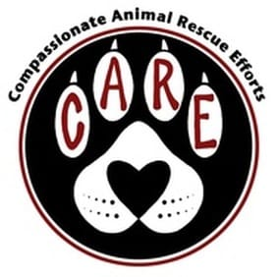
JUNIOR VOLUNTEERS
PERMISSION AND RELEASE FORM

CARE – compassionate animal rescue efforts
P O Box 72, Catoosa, OK 74015
PH: 918-280-8146

Permission & Release Form for Junior Volunteer(s)
This form is to be filled out by parent or legal guardian along with young
volunteer.

Please read and complete this form, sign it and return it to us.

Please Print All Information!
Please circle one: Parent Legal Guardian

Parent’s/Legal Guardian’s Name: ________________________________
I give permission for the following child to participate in
the CARE’s activities:

Child’s Name: __________________________________ Age: _______

D.O.B. month __________________ day ________ year ____________

Address (street): _____________________________________________

City: _________________________ State: _______ Zip: ____________

Daytime Phone #: ______________ Evening Phone #: ______________

Emergency Phone #: ____________ Email: _______________________

School Attending: ____________________________________________

Describe experience with dogs and cats:________________________________________________________

Do you presently own any cats or dogs?
__________________________________________________________

Permission & Release of Liability

Please Initial

______ My child/children will abide by the mission, rules, regulations,
policies and programs of CARE rescue
while I am a volunteer.
______ I assume the risks of my child/children being bitten, scratched,
injured or frightened by cats, kittens, dogs and puppies in
connection with my volunteer work for CARE rescue.
______ CARE rescue is not liable for any injuries,
damages, liabilities, losses, judgments, costs or expenses
whatsoever, which my child/children might suffer or sustain in
connection with the performance of their volunteer activities for
CARE rescue.
______ I hereby release and indemnify, defend and hold harmless CARE rescue, its directors, officers,
employees, agents, and volunteers and their heirs, successors,
assigns personal representatives from and against liability.
______ I have accurately and truthfully completed this volunteer
application.

Parent/Guardian Youth Volunteer Applicant
__________________________________________________________
Sign Name
__________________________________________________________
Print Name
__________________________________________________________
Date

FOR OFFICE USE ONLY
Rescue Manager/Assistant Manager Youth Volunteer Coordinator

Sign Name
__________________________________________________________________
Print Name
__________________________________________________________________
Date

